**Stats 201 HW9**

Answers for Nov. 24:

1.

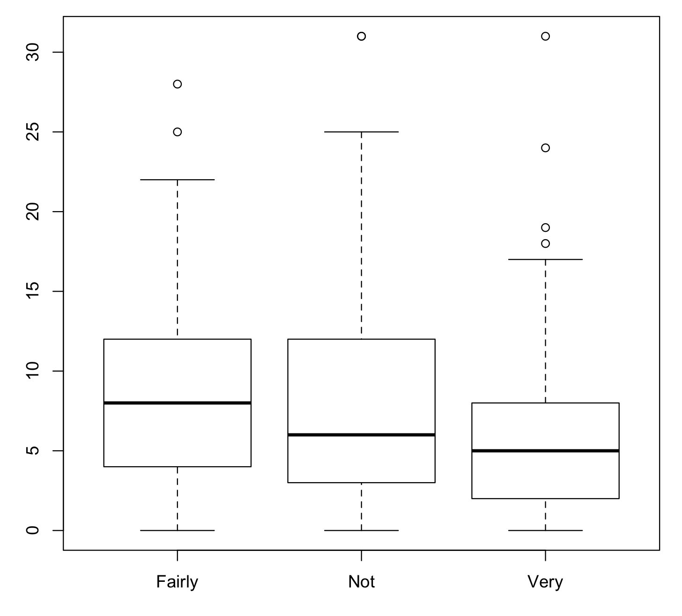

2.

Sample means:

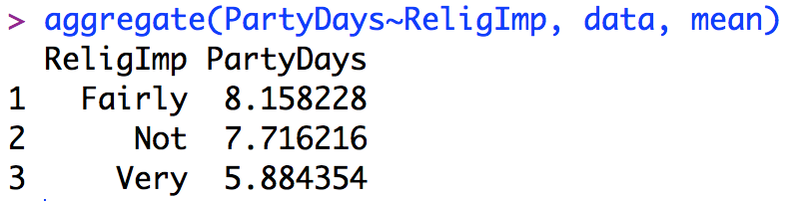

Sample standard deviations:

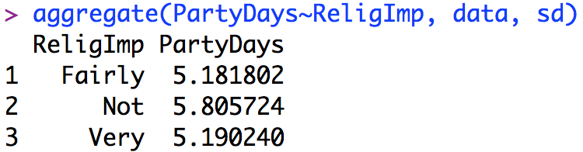

Sample sizes:

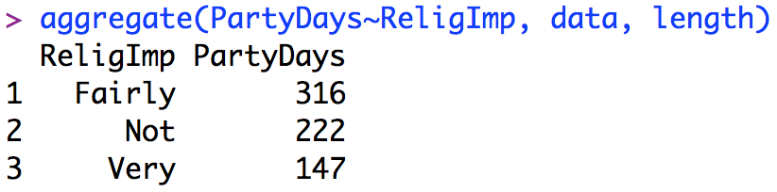

3. Yes. These three groups have about the same standard deviation but different levels of means, and this might suggest that there are differences among the groups.

4.

(a) Group means model: Yij = μi + εij, where Yij is the value for level i and unit j, ui is the mean for level i, and εij is the individual error. Yij ~ N(ui, σ2)

(b) Factor effects model: Yij = μ + αi + εij, where Yij is the value for level i and unit j, μ is the mean for all cases, αi is the effect (difference) of level i from μ, and i = 0

(c)

(1) Group means model:

H0: μ1 = μ2 = μ3, which means in the student population, the average party days of different religion groups are the same.

Ha:not all ui’s are the same, which means in the student population, not all religion groups have the same average party days.

(2) Factor effects model:

H0: α1 = α2 = α3 = 0, which means in the student population, different religion groups have no effects on party days.

Ha:not all αi’s are zero, which means in the student population, different religion groups might have different effects on the average party days.

5.

(a) H0: μ1 = μ2 = μ3, which means in the student population, the average party days of different religion groups are the same. Ha:not all ui’s are the same, which means in the student population, not all religion groups have the same average party days.

(b)

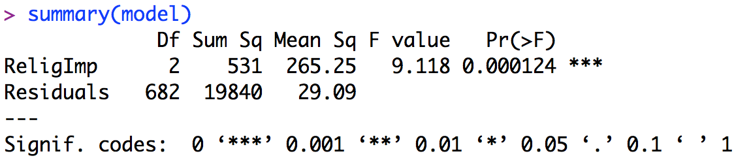

(c) Test statistic: 9.118, p-value: 0.000124

(d) The p-value (0.000124) is small (< 0.05), so reject H0, which means in the student population, not all religion groups have the same average party days.

6.

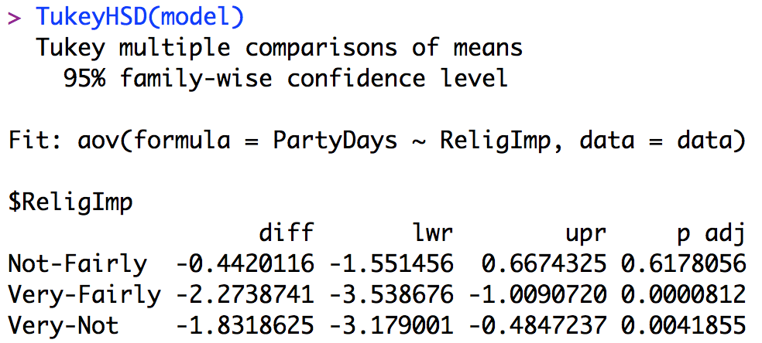

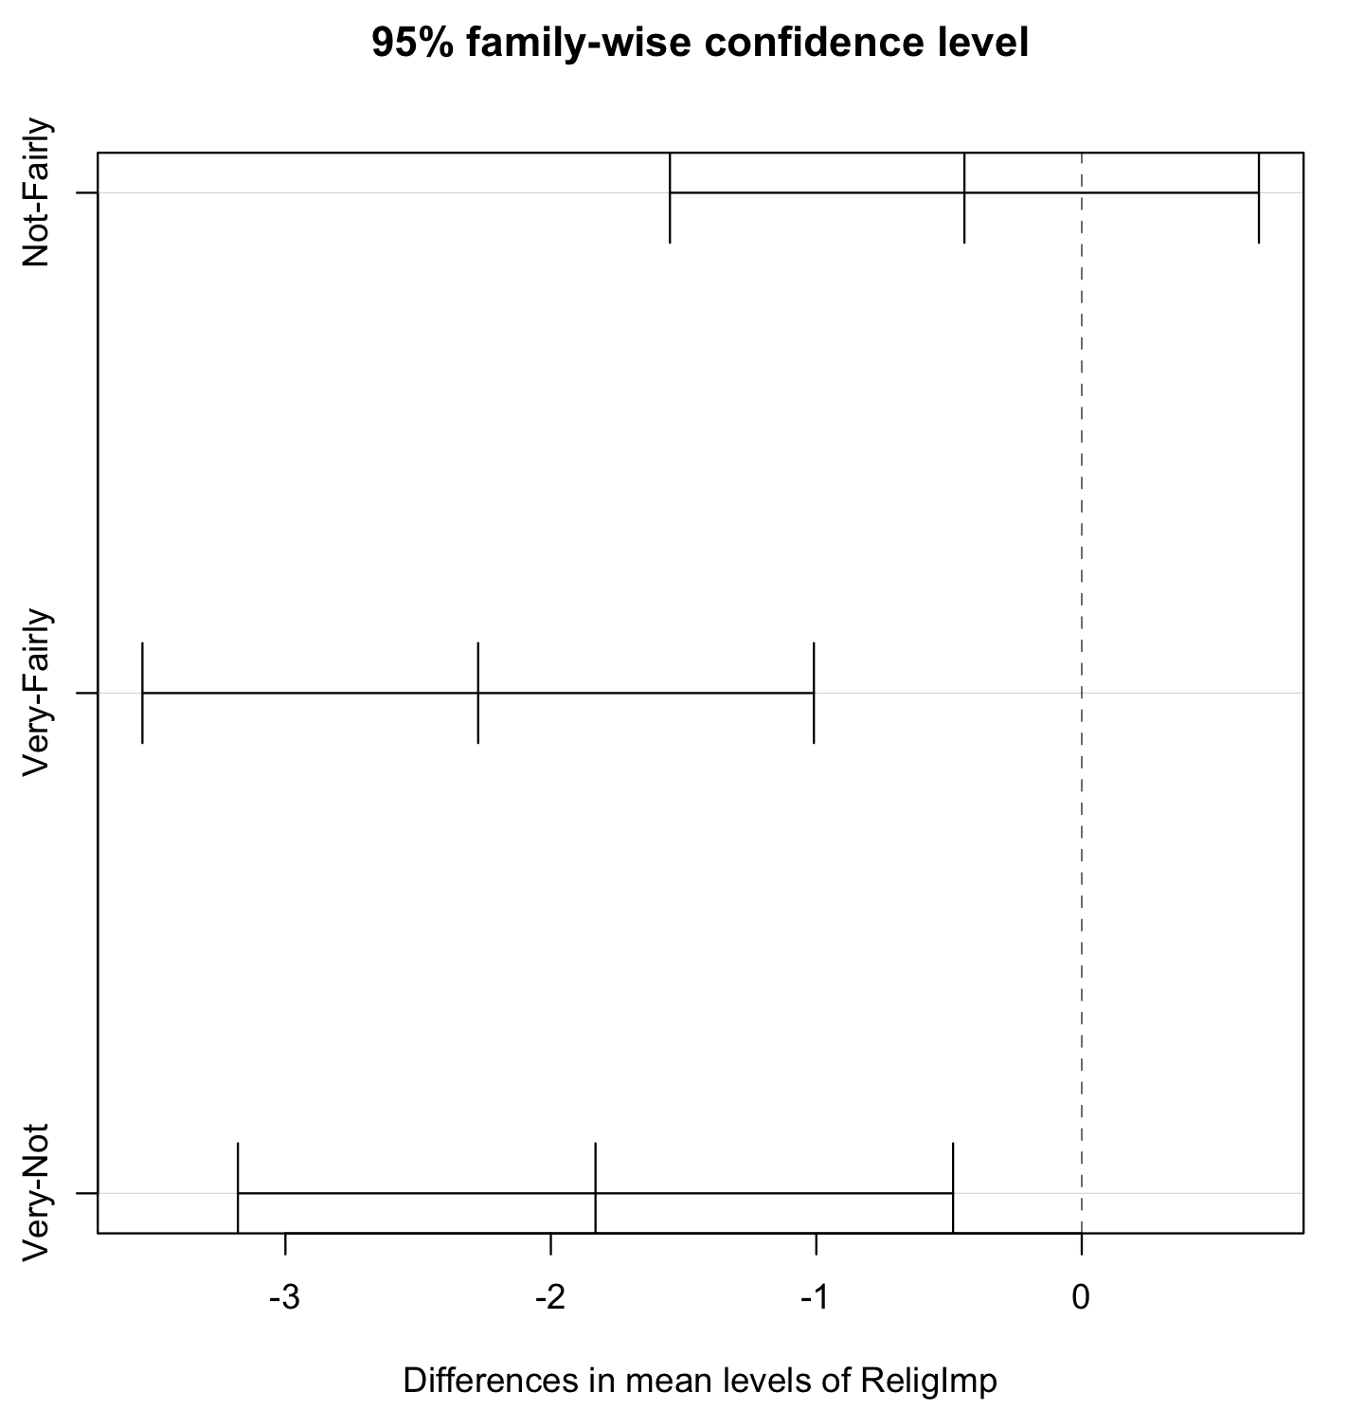

From the Tukey multiple comparisons procedure, we can see that 0 is not covered in the differences of (Very, Fairly) and (Very, Not). Therefore, we conclude that in the student population, the average party days between (1) very religious and fairly religious, (2) very religious and not religious are different.

Answers for Nov. 27:

S4.4

Yes, there appears to be an interaction between them.

Interaction plot:

S4.10:

1. Yes. The plots (lines) of different sites are different. Arctic has a bigger intercept and its mean DDT is higher than the other two; the intercepts of U.S. and Canada are about the same, but their slopes are slightly different.
2. Yes. The mean DDTs of different ages are different. DDT appears to be increasing with age.
3. No. The slopes of the lines of the three sites appear to be about the same.

S4.11

1. H0: In the falcon population, the mean DDTs of different sites (Arctic, U.S., and Canada) are the same. Ha: In the falcon population, the mean DDTs of different sites are not all equal.
2. H0: In the falcon population, the mean DDTs of different ages (Young, Middle, and Old) are the same. Ha: In the falcon population, the mean DDTs of different ages are not all equal.
3. H0: In the falcon population, the relationship between mean DDT and site does not depend on their ages. Ha: In the falcon population, the relationship between mean DDT and site depends on their ages.

S4.12

1. From the two-way ANOVA we can find the p-value of site is small (0.000), so reject H0, which suggests there is a site main effect.
2. From the two-way ANOVA we can find the p-value of age is small (0.000), so reject H0, which suggests there is an age main effect.
3. From the two-way ANOVA we can find the p-value of the interaction is big (0.313), so do not reject H0, which suggests there is no interaction effect.

S4.13

1. In Arctic, the average DDTs of all levels of ages are higher than the other two sites. For U.S. and Canada, the average DDTs of all levels of ages are about the same.
2. For all sites, the average DDT increases with age.
3. No. Because in the interaction plot we can see that the slope of the three lines are about the same, and in the ANOVA table we get a p-value of 0.313, which is not statistically significant to conclude there is an interaction effect.

S4.14

MSE = 3.44

For A, F* = MSA/MSE = 8892.7 / 3.44 = 2585.08

For B, F* = MSB/MSE = 860.59 / 3.44 = 250.17

For AB, F* = MSAB/MSE = 1.28 / 3.44 = 1.287

Answers for Dec. 2:

S4.5

a. 8.0 b. 7.1 c. μ1. = 7, μ2. = 7.2 d. μ.1 = 6.5, μ.2 = 7.7

S4.6

1. α1 = 7 – 7.1 = -0.1, α2 = 7.2 – 7.1 = 0.1
2. β1 = 6.5 – 7.1 = -0.6, β2 = 7.7 – 7.1 = 0.6
3. αβ11 = 6.0 – (7.1 – 0.1 – 0.6) = -0.4

αβ12 = 8.0 – (7.1 – 0.1 + 0.6) = 0.4

αβ21 = 7.0 – (7.1 + 0.1 - 0.6) = 0.4

αβ22 = 7.4 – (7.1 + 0.1 + 0.6) = -0.4

S4.7

Additive model: μij = μ.. + αi + βj

μ11 = μ.. + α1 + β1 = 7.1 – 0.1 - 0.6 = 6.4 ≠ 6.0

μ12 = μ.. + α1 + β2 = 7.1 – 0.1 + 0.6 = 7.6 ≠ 8.0

μ21 = μ.. + α2 + β1 = 7.1 + 0.1 - 0.6 = 6.6 ≠ 7.0

μ22 = μ.. + α2 + β2 = 7.1 + 0.1 + 0.6 = 7.8 ≠ 7.4

It seems like the additive model is not adequate.

S4.8

Full model: μij = μ.. + αi + βj + αβij

μ11 = μ.. + α1 + β1 + αβ11 = 7.1 – 0.1 - 0.6 – 0.4 = 6.0

μ12 = μ.. + α1 + β2 + αβ12 = 7.1 – 0.1 + 0.6 + 0.4 = 8.0

μ21 = μ.. + α2 + β1 + αβ21 = 7.1 + 0.1 - 0.6 + 0.4 = 7.0

μ22 = μ.. + α2 + β2 + αβ22 = 7.1 + 0.1 + 0.6 – 0.4 = 7.4

S4.9

From the table we can see that the population mean sleep hours of non-coffee drinkers is higher than coffee drinkers in both two levels of ages, but the difference mean sleep hours between non-coffee drinkers and coffee drinkers depend on their age: for age 18-21, the difference is bigger (1.0); for age over 21, the difference is smaller (0.4).